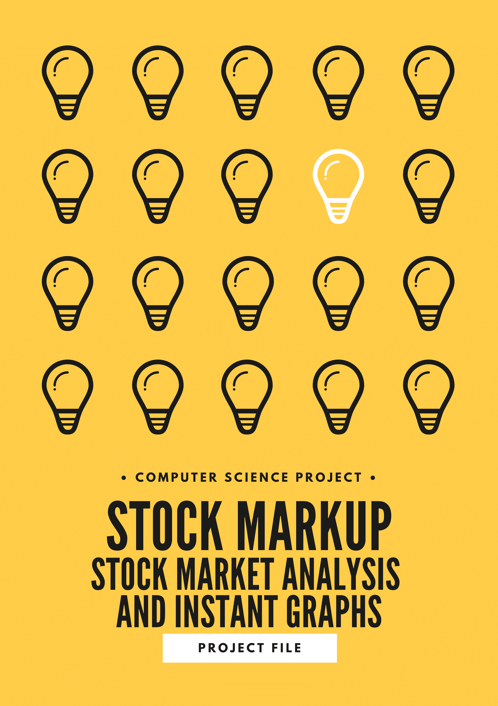

|  |  |  |  |  |  |  |  |  |  |
| --- | --- | --- | --- | --- | --- | --- | --- | --- | --- |
| |  | | --- | | **A N A N D A L A Y A**  N.D.D.B. Campus Anand.  (02692) – 262200, 261069  E-Mail: office@anandalaya.ac.in  Website: http://www.anandalaya.ac.in |   **C E R T I F I C A T E**  This is to certify that  **Daksh Dadhania** Roll number: **____5____** of class 12-**__A__** of Anandalaya, has successfully completed his investigatory project titled **“_STOCKMarkup_”** as a part of partial completion of the subject *Computer Science - Practical* for the academic year 2020-21.   |  |  | | --- | --- | | Teacher’s Signature | Principal’s Signature | |  |  | | Date: **___15/12/2020____** |  | | Place: **__ANAND_______** |  | |

**Acknowledgment**

It would be my utmost pleasure to express my sincere thanks to our principal **Sh. Pawan kumar Sharma** who gave me the golden opportunity to carry out this project.

I express my sincere thanks to our Computer Science Teacher **Mr. Alpesh Shah Sir** for his constant support and also **Mr. Nilken Suthar Sir** for providing a helping hand in the project. Their valuable guidance, support and supervision all through this project titled “**StockMarkup: Stock Market Analysis And Instant Graphs**”, are responsible for attaining its present form.

I would like to express my sincere thanks to my team members **Jyot Thesia** and **Rhythm Bansal** whose leadership in the project has been detrimental in its building.

I would like to express my gratitude to my parents who have not only provided the infrastructure but the motivation to carry out the project on such a noble idea.

Finally I would like to thank all those who have directly and indirectly lent their hand in the making of this project.

**DAKSH DADHANIA**

**XII A**

**RollNo-5**

|  |  |  |
| --- | --- | --- |
| SrNo. | **INDEX** | Page No. |
|  | Certificate | 2 |
|  | Acknowledgement | 3 |
| 1 | Abstract | 5 |
| 2 | Introduction | 5 |
| 3 | About Python | 6 |
| 4 | System Analysis | 7 |
| 5 | Data Flow Diagram | 7 |
| 6 | System Requirement | 10 |
| 7 | Project Code | 10 |
| 8 | Screenshots | 11 |
| 9 | Bibliography | 14 |
| 10 | Individual Contribution | 14 |

**1) Abstract**

**STOCKMarkup** is a stock market analyser which gives a great helping hand to those who want to have watch on stock market. The system would provide instant details of any stock through direct data sourcing from official NSE website, it can also give market top GAINERS and LOSERS for realtime when market is open... The main feature of the project is to make real time graph of any stock for any number of observations and for any time interval and the program will auto refresh for making csv file and plot graph..

**Data Sourcing** (also Data Collection) is the process of extracting data from external or internal (front/back office systems) comprising an institution's [Data Infrastructure](https://www.openriskmanual.org/wiki/Data_Infrastructure) for diverse purposes. Development include the establishment and maintenance of back-end database that is CSV file for our program (which will be automatically be created when program is run) and front-end application development aspects (that is our python file).

This system is a culmination of using python built-in libraries, custom built functions and CSV databases.

**2) Introduction**

The project titled “**STOCKMarkup: Stock Market Analysis And Instant Graphs**” is a stock market analyser built on python code with additional use of CSV database system. It can be used for individual stock references and also by any organisation. It'll be creating several databases of realtime stock prices to allow our program to plot the graph which are fulfilled by the algorithm.

**3) ABOUT PYTHON**

**What is python ?**

Python is an interpreted, high-level, general-purpose programming language. Created by Guido van Rossum and first released in 1991, Python's design philosophy emphasizes code readability with its notable use of significant whitespace. Its language constructs and object-oriented approach aim to help programmers write clear, logical code for small and large-scale projects.

Python is dynamically typed and garbage-collected. It supports multiple programming paradigms, including structured (particularly, procedural), object-oriented, and functional programming. Python is often described as a "batteries included" language due to its comprehensive standard library.

Python was conceived in the late 1980s as a successor to the ABC language. Python 2.0, released in 2000, introduced features like list comprehensions and a garbage collection system with reference counting.

**Why Python :**

**Advantages of using python for implementing :**  
1) Presence of third-party modules  
2) Object-oriented language  
3) Open source and community development  
4) Easy to learn  
5) User-friendly data structures  
6) High-level language  
7) Dynamically typed language(No need to mention data type based on value assigned, it takes data type)  
9) Portable and Interactive across Operating systems

**How Python Works:**

Python is an interpreted, object-oriented, high-level programming language with dynamic semantics. Its high-level built in data structures, combined with dynamic typing and dynamic binding, make it very attractive for Rapid Application Development. Python supports modules and packages, which encourages program modularity and code reuse.

**3) SYSTEM ANALYSIS:**

**EXISTING SYSTEM**

System and their relationships within and outside of the system. Analysis begins when a user or manager begins a study of the System Analysis is a detailed study of the various operations performed by a program using existing system. During analysis, data collected on the various files, decision points and transactions handled by the present system. The success of the system depends largely on how clearly the problem is defined, thoroughly investigated and properly carried out through the choice of solution. A good analysis model should provide not only the mechanisms of problem understanding but also the frame work of the solution. Thus it should be studied thoroughly by collecting data about the system. Then the proposed system should be analyzed thoroughly in accordance with the needs.

**4) DATA FLOW DIAGRAM**

A data flow diagram, also known as “bubble chart” has the purpose of clarifying system requirements and identifying major transformation that will become programs in system design. It is a graphic representation of a system or portion of system. A DFD consists of a series of bubbles joined by lines. It consists of data flows, processes, sources, destinations and stores all described through the use of easily understood symbols. An entire system can be described from the viewpoint of the data it processes with only four symbols. The DFD is also powerful enough to show parallel activities.

**TYPES OF DATA FLOW DIAGRAM**

• Physical data flow diagram: -Physical data flow diagram is implementation dependent. They show the actual devices, department, people etc. involved in the current system.

• Logical data flow diagram: - It describes the system independently of how it is actually implemented, that is , they show what takes place, rather than how an activity is accomplished.

COMPONENTS OF DATA FLOW DIAGRAM

a) Source or Destination: -The source or destination is graphically represented as a rectangle. Source or destination external entities with which the system communicates. A source or destination is a person or a group of persons that are outside the control of the system being modeled.

b) Data Flow: -The flow is represented graphically by an arrow into or out of a process. The flow is used to describe the movement of chunks or packet of information from one part of the system to another part. The flow represents data in motion.

c) Process: -The process shows a part of the system that transforms input into output. The process is represented graphically as a circle or bubble. d) Data Store: -The data store is used to model a collection of data packet at rest. The notation of a data store is two parallel lines. Data stores are typically implemented as files or databases in computerized system. Data stores are connected by flow to processes.

OUR FLOW CHART

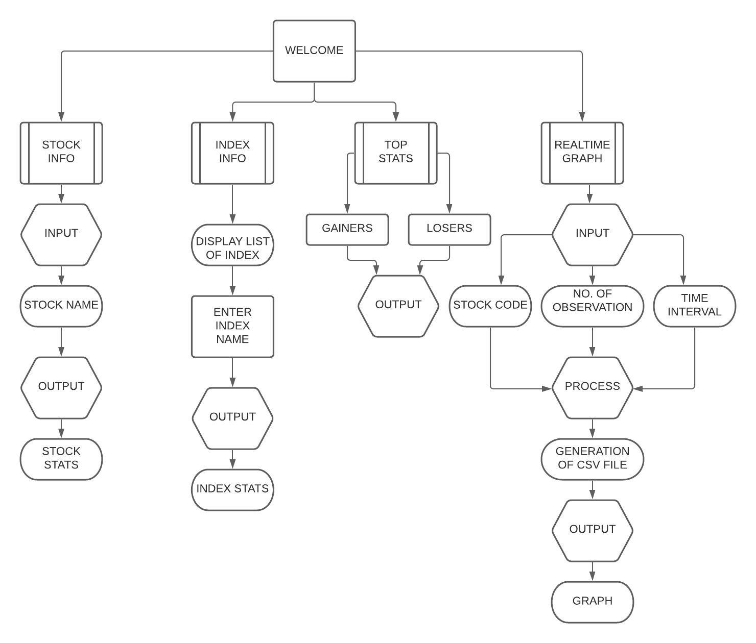

**6) SYSTEM REQUIREMENT**

1) CPU- Intel Core 2 Duo 2.8Ghz or AMD A4-4000 x86 64-bit

2) Ram – 4Gb or more

4) 5GB free disk space

5) Windows 8.1 ( 64 bit ) or Mac OS Snow Leopard or above

6) MS Office 2007 or above

**7) Project Code**

**Link to the CODE-** [Click Here](https://drive.google.com/drive/folders/1uXvysLJbEksEWKnrRxt_5UhknWd6N8Zn?usp=sharing)

1. **SCREENSHOTS**

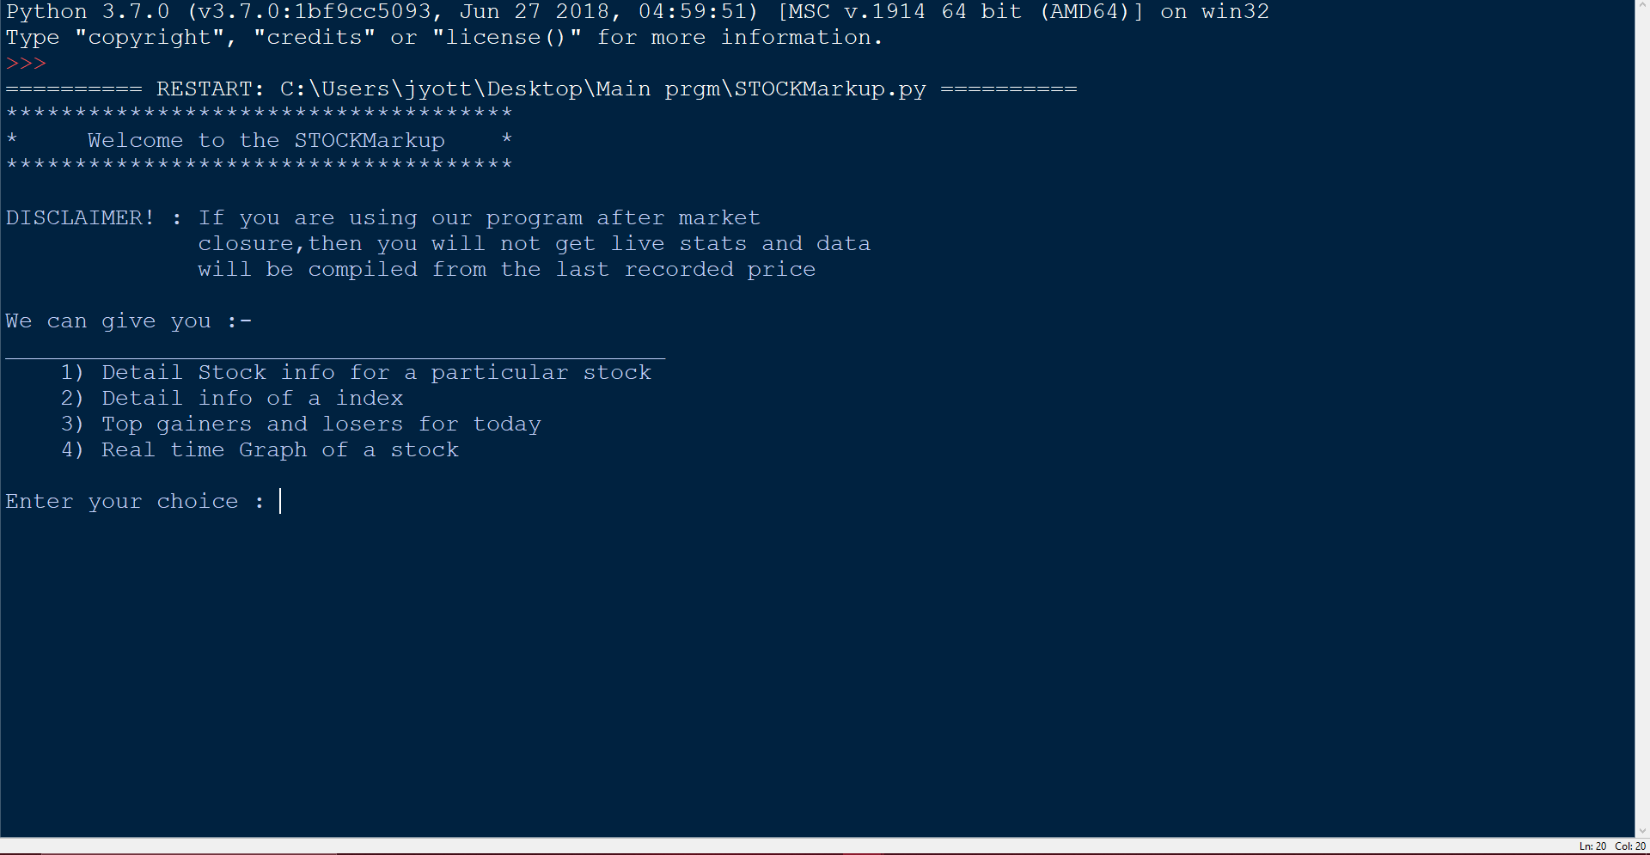

(1.)This is the initial screen which welcomes you and shows disclaimer and features what the program offers to the client.

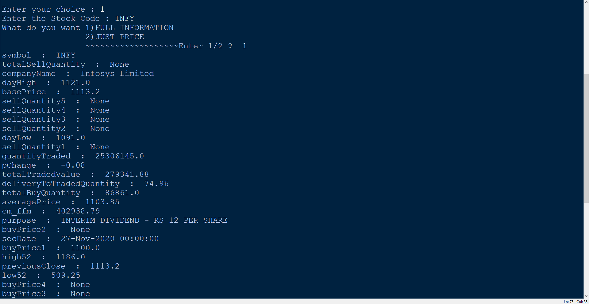

(2.)If you chose to view detailed stock info, you need to enter the stock code.

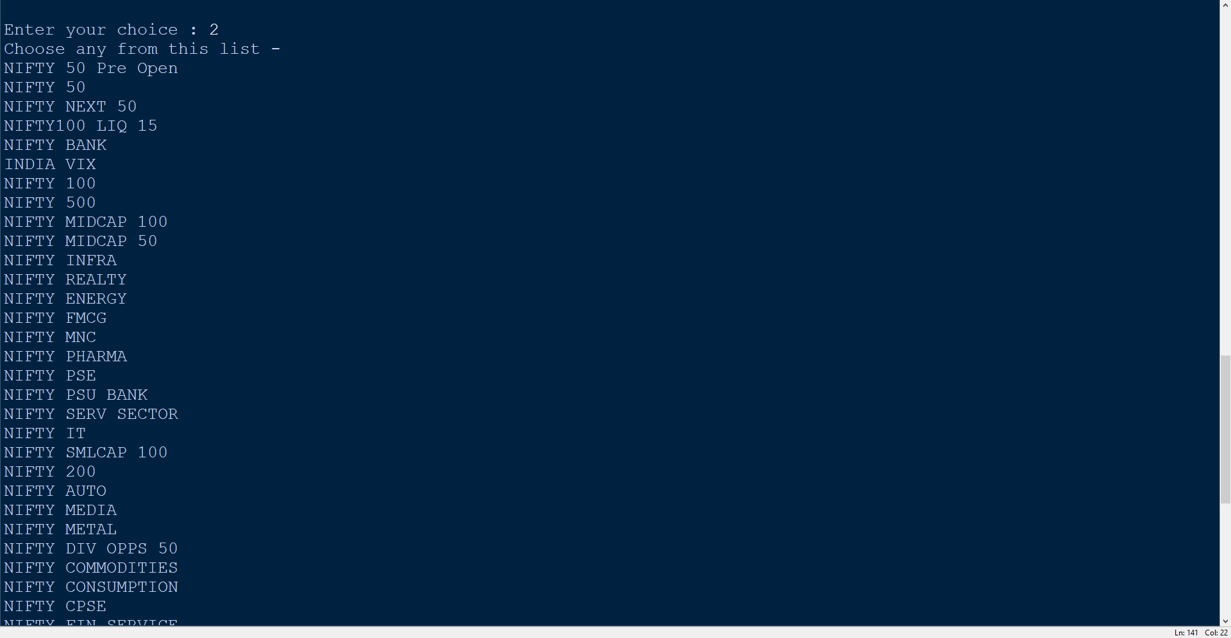

(3.)If you chose to view detailed info of an index, then enter an index from the given list and it will give an output as followed.

4

(4.)This the detailed info of an index

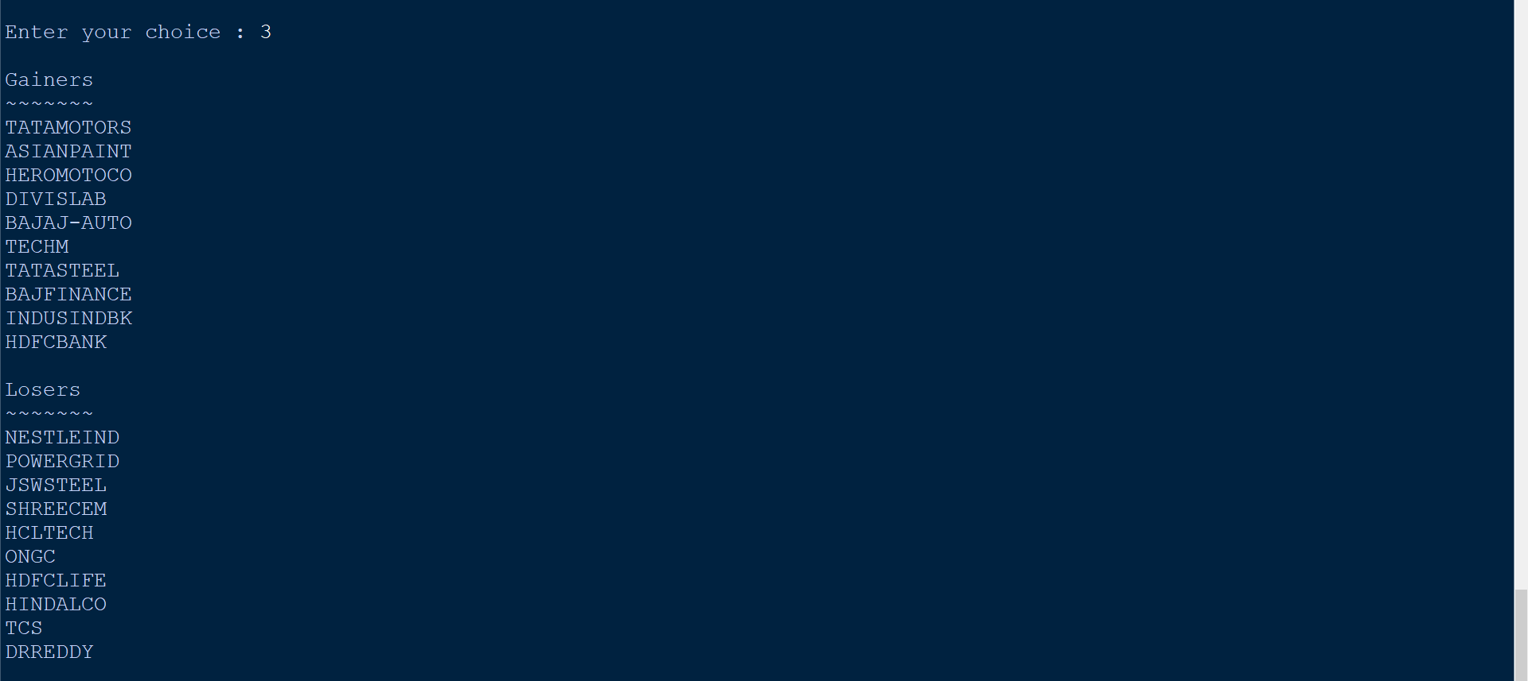

(5.)If you chose to view the top gainers and losers, the program will directly give you a list of the top gainers and losers.

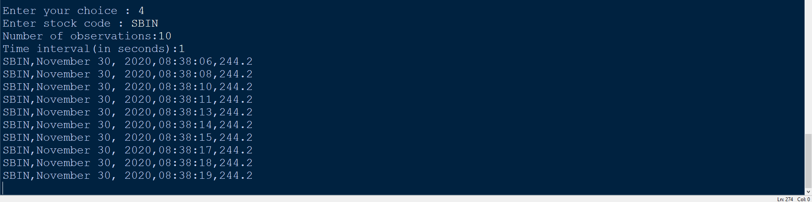

(6.)If you chose to view realtime graph of a stock, then enter the code of the target stock , number of observations you would like to take and the time interval between each reading.

The output shows: STOCK_CODE,DATE,TIME,PRICE

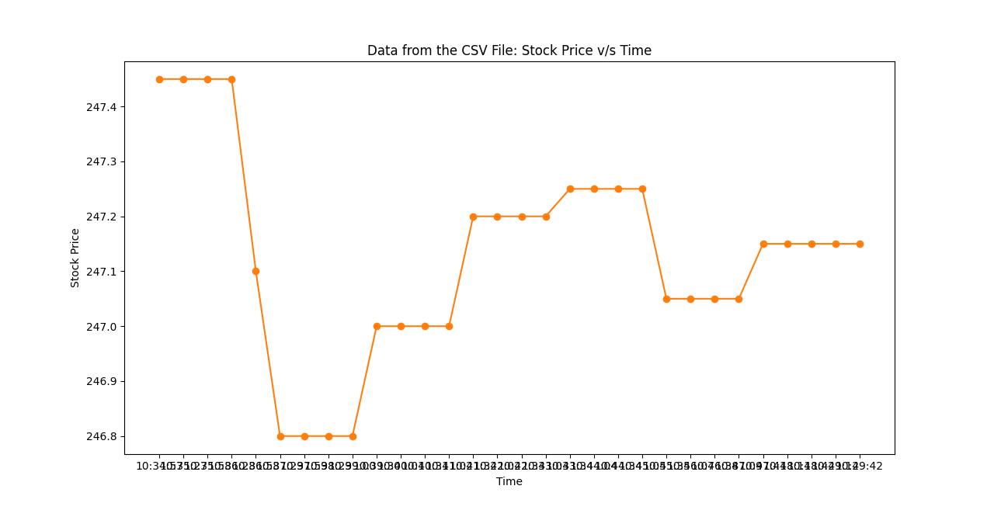

(7.)The graph between Stock Price and Time will be plotted and will be showed on another window.

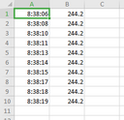

(8.)The Time and Stock Price will also be saved on another CSV file on your storage disk.

**9) Bibliography**

**i)**[**https://www.w3schools.com/python**](https://www.w3schools.com/python)

**ii)**[**3.9.0 Documentation (python.org)**](https://docs.python.org/3/)

**iii)**[**https://pypi.org**](https://pypi.org/)

**Books:**

**i) Computer Science with Python by Sumita Arora**

**10) INDIVIDUAL CONTRIBUTION TO PROJECT CODE:**

**1) Collection of data from NSE servers for STOCKMarkup**

**2) Word file writeup**

**3) Data flow diagram**

**4) Using nsetools module in python**

**5) Stock info and Top gainers and loosers extraction**